**Innovation, Employability Professional Readiness for**

**and Entrepreneurship**

ASSIGNMENT 1

SMART HOME

Submitted by,

Dafni Leenel N L

Reg No. 961819106017

Batch:- B12-6A2E

SMART HOME

CODE FOR SMART HOME:-

#include <Servo.h>

int position = 0;

int i = 0;

int j = 0;

Servo s;

void setup()

{

s.attach(9, 500, 2500);

Serial.begin(9600);

pinMode(13,OUTPUT);

}

void loop()

{

position = 0;

for (position = 1; position <=179; position += 1) {

s.write(position);

delay(100);// Wait for 100 millisecond(s)

double a=analogRead(A0);

double t=(((a/1024)*5)-0.5)*100;

Serial.print("temperature");

Serial.print(t);

if(t>100){

digitalWrite(13,1);

}

}

}

CIRCUIT DIAGRAM FOR SMART HOME:-

Tinker cad link: <https://www.tinkercad.com/things/2cBkSFxqN30-smart-home>

SNAPS OF SMART HOME:-

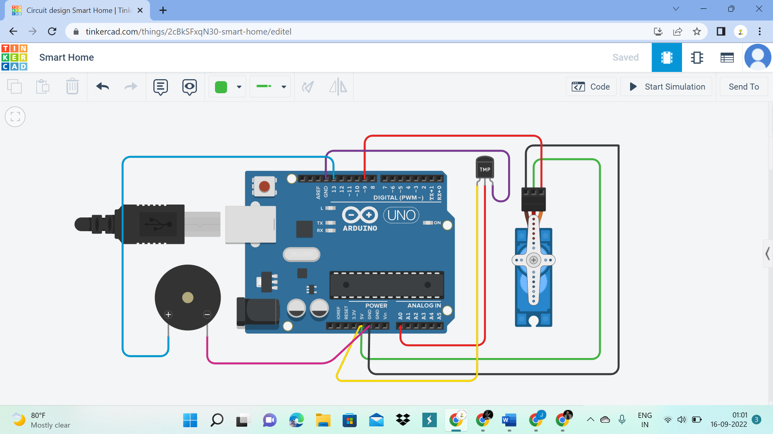

The above circuit diagram shows the smart home application in which a room is connected with micro servor and temperature sensor start to detect the temperature in the room. If the temperature is greater than 100 degrees, then the Buzzer connected to the temperature sensor start to make beep sound.